Conscious Competence Ladder

This framework breaks down the stages that every single individual has to go through to achieve success. This is an important process for clients to be aware of before launch so that they are prepared for Stage 2 and have the awareness to identify it and move forward with a positive mindset. It can be helpful to put this into context for the client by using someone on their fitness journey as an example.

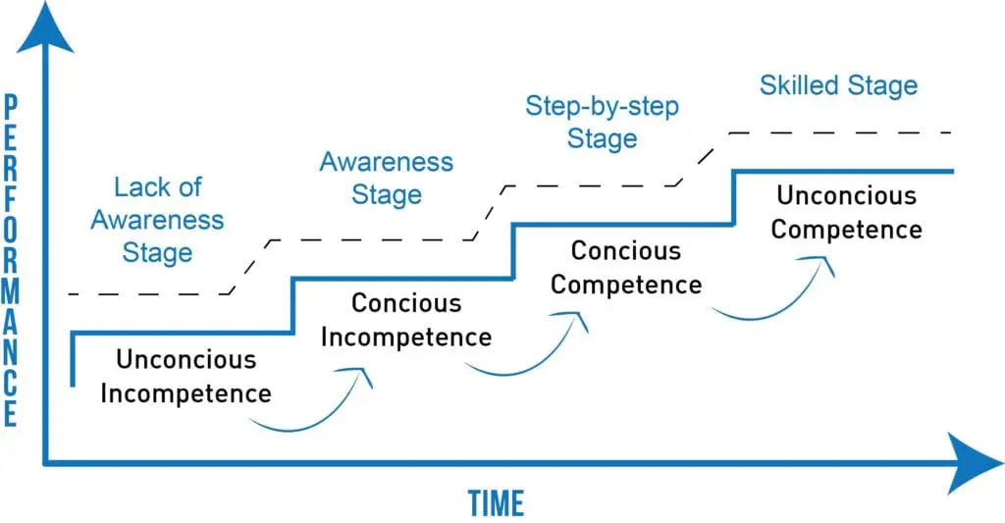

1 - Unconscious Incompetence Stage

You don’t know what you don’t know/the client is unaware of what they don’t know or the skills they will need.

The client is still onboarding, excited to launch and make money. The client is excited, not thinking about what is to come and the work that will be needed to scale their business.

This can also be just after launch when the client is making initial sales

2 - Conscious Incompetence Stage

The client becomes aware of the skills they need to scale their business but does not yet know how to act on this. Everyone will hit this stage, whether it's 2 weeks or 2 months after launch. 80% of people at this stage will fail and quit, this won’t be the client.

Sales dry out for the client and they start to worry that they are not good enough or that others are better than them

Once you are at this stage, tell me/email me - we need to be aware and have support to get to Stage 3. Use the Growth Wheel Framework to identify issues and use:
- Consistency
- Persistence
- Testing
- Tweaking
- Analyzing
- Dedication
- Hard work

The combination of strategy and hard work will allow the client to reach Stage 3

3 - Conscious Competence Stage

The client begins to learn what they need to do to keep scaling their business. There are still things to work on but improvements/sales are being made.

4 - Unconsciously Competent Stage
The client becomes confident and knowledgeable in what they need to do to keep scaling their business. A clear strategy of getting results. The hard work must continue

